**430** 心理学研究 2012 年 第 83 巻 第 5 号

心理学研究 2012 年 第 83 巻 第 5 号 pp. 430-439

**Original paper**

**Optimistic cognitive bias in** **college students' requests for help with depressive symptoms**

**Yusuke** Umegaki 1,**Masato Kimura,The University of Tokyo,Osaka International University**

**Optimistic bias in help- seeking intentions and behaviors for depressive symptoms Yusuke Umegaki** (*University of Tokyo*) **and Masato Kimura** (*Osaka International University* )

The present study investigated the effect of optimistic bias on help-seeking intentions and behaviors in relation to health care professionals and nonprofessionals for depressive symptoms. In addition, the study tested the hypothesis that seeking help from professionals poses a greater threat for self-esteem than from

non-professionals. A questionnaire survey (*N* = 462) using clinical vignettes was conducted with university

students. The results suggested that optimistic bias had an impact on help-seeking intentions and behaviors

directed towards both health care professionals and nonprofessionals. There seemed to be a relatively stronger threat to self-esteem in help-seeking involving nonprofessionals and a weaker threat in help-seeking involving professionals, contrary to previous studies. The results were explained by the threat to self-esteem and equity theories. Understanding the rationale of optimistic bias and symptom recognition in the help- seeking process may provide relevant information to bridge the service gap in the treatment of depression.

**Key words:** help-seeking, optimistic bias, depression, self-esteem, equity.

*The Japanese Journal of Psychology*

2012, Vol. 83, No. 5, pp. 430-439

When you are faced witha problem that you can't do withyourown power,The otherTo theI'm singI'm going toThetoThe ideaYou canIn addition, the an actionthatseekshelpfrom another person is an act of request for help definedby the conceptof , problem solving or directingto it an activeaction that is done for the purpose of collecting information., Adaptive importanceWhat is it?ActionAnd theThe ideaIt is possible toIn addition, the

anareawheretheconceptof an aid request isparticularlyimportantAs a, andMental HealthThe areaThere isIn addition, the solvingmental health problems such as mental disorders to relieve , suchas medical treatmentorpsychotherapyProfessionalWhat is it?AssistanceIf there is aNeededIt isIf youIf there is aManyif you want to, Specialized InstitutionsTo theTo theTo doRequest for helpIf there is aTheIn order to be able toIn addition, the

However, in the field of mental health, while there are proven treatment and assistive techniques, many people do not seek help(Ciarrochi, Deane,

Wilson, & Rickwood, 2002; Gulliver, Griffiths, &

Correspondence concerning this article should be sent to: Yusuke Umegaki, Department of Clinical Psychology, Graduate School of Education, University of Tokyo, Hongo, Bunkyo-ku, Tokyo 113-0033, Japan (e-mail: umegaki.yusuke@mail.u-tokyo.ac.jp)

1 Japan Society for the Promotion of Science

Christensen, 2010）。 治療・援助サービスの担い手と受け手との間のこのようなギャップは service gap と定義され（Kushner & Sher, 1991; Stefl & Prosperi,

1985),Filling this gap is a majorin mental health measures has become oneof the major challenges.

A representative example of service gapin the mental health field is major depressive disorder(depression)There is a problem of depression. According to Kawakami(2003), even people with depressive symptoms that meet the diagnostic criteria for depression, Only 25percent said they made a request for help to a medicalinstitution. In addition, the percentage of people who have depressive and anxiety symptoms who have depressive and anxiety symptoms who seek specialized treatment and support services is18-34 About %

(Gulliver et al., 2010)

A person with depressivesymptomshasa low rate ofvisitsIf you areThe backgroundAs a, andDepressionDiseaseorPsychiatric examinationThey are related toPrejudiceIncludingA variety ofat the level ofFactorsYou can use theThe ideaYou can, SymptomsYou can use theTheTo doThe PeopleYou can use theAppropriate forWhat is it?Treatment- I'm sAssistanceTo connect to, The person in questionIf there is aThe problemorSymptomsYou can use theRecognitionAnd then, AssistanceYou can use theRequesttrying toThe ideaTo beExpectationsMust beThe partWell, alsoLarge.I'm good.In addition, the the sideof andonor to all whoexhibit symptoms FromExtractionTo beLimitsbecause there isIn addition, the

There are many studies that model the decision-making process until the action of the request for assistance (Aikawa,1989; Cauce & Srebnik, 2003; Kuda,2000; Srebnik, Cauce, & Baydar,

1996; Takano- I'm sUrada,2002), both of which are the firststeps of the processasthe existenceof aproblemTo theMind you.It's not aThe stageYou can use theSet upAnd thenif you want toIn addition, the If you don'trealizethere's a problem, ask forhelp.because it is considered not necessary.But, for mental health problems, symptomsand thedifficulty of noticinga problem such as an incident (Kuda,2000;Umegaki,2011I'm singing.Asafactorthat makesitdifficult to notice a problem, 2011)quantitativelygraspincidentsOf theDifficultyIs it?, Physical SymptomsYou can use thePsychological factorsTo theAttributionOf theDifficultyYou can use theThe information isThey areIn addition, the However,noticingtheproblem is that have depressedsymptoms,or depression it is also toadmit that it is a state. depressionor psychiatric examinations. theexistence of aproblem because of the stigma becomeathreattoself-esteem(Nadler ,1991),therebyacknowledgingtheproblemAnd theDifficultyIt's a goodSideAnd there is, tooThe ideaIt is possible toIn addition, the

A study of the recognition of the problem of the request scene for the help of depressive symptoms isSpendelow & Jose(2010). The study conducted a questionnaire survey using a scene-based method for university students to examine whether optimistic cognitive bias works when considering requests for help with depressive symptoms. Optimistic cognitivebias is one of self-serving biases.

(Friedrich, 1996), in situations that are not favorable to you,to evaluate their situation more optimistically thanit's about intellectual bias.(Rothman, Klein, & Weinstein, 1996;Weinstein,1980I'm singing. The study found that people who showed depressive symptoms than their friends tended to evaluate their severity, prognosis, and the importance of requests for assistance with significant optimism. From these results, it was shown that optimistic cognitive bias works in the scene of requesting help for depressive symptoms of university students, and it was thought that it might be a obstruction factor of the request for help. However, the study did not identify the person who requested help when exhibiting depressive symptoms. When you actually have depressive symptoms, it is a cognitive difference whether you consider a request for help for an informal subject such as family or friends, or a doctor or a psychologist. (Raviv, Sills, Raviv, & Wilansky, 2000).When you ask a doctor or psychologist for help compared to asking for help from family and friends, it is a bigger cognitive threat because of stigma associated with depression and psychiatric examinations. It is presumed that. Raviv et al.(2000)isTen.a young man in his teens optimistic cognitive bias tends to be strengthened when investigating the intention sought assistance and considering requests for help from specialists such as psychologists and school counselors. This is considered to be a greater threat to self-esteem, but in situations where depressive symptoms are presented,

ina request for assistancetothe gate , greaterself-esteem is consideredtobeperceived as athreattoTherefore , in the verdictofa friendis anexpertand a significantchange in the ratingof non-professional I'm not.To theAnd then, myselfAbout TheGradeTo doIf youisNon-professionalTo theTo theTo doThe ReviewIn this way, theIf there is aRelativeTo theHighif you want to, ExpertsTo theTo theTo doGradeisRelativeTo theLowand then, BothTheThe differenceIf there is aLarge.to becomeThe ideaIt is possible toIn addition, the

For the above reasons , consider the cognitivebias regarding the request for assistanceon, informal and formalhelpersDistinctionAnd thenConsideringTo doNeededand there isThe ideaIt is possible toIn addition, the Also,likeSpendelow & Jose(2010)not only the importanceofan aid request,but alsoanactual request for assistance actionTo theIn the near-timeIf you areThe variableYou can use theMeasuringTo beTheThey areIn addition, the

In this study, we request edits for help ondepressivesymptoms of college students.Reviewed therecognitionof. thelimitsof thepreceding researchdescribed aboveYou can use theTreadCome on., AidesTheThe difference.Depends on theRecognitionTheVarianceYou can use theConsideringtoThe AimDid youIn addition, the as a concrete helper,to a formalhelperassume an expertin medical and psychological assistance,FormalAction for AssistanceYou can use the(Hospital)

（する） という概念で定義した。 また，インフォーマルな援助者として家族や友達を想定し，家族や 友達への援助要請行動を （家族や友達に）相談（する） という 概念で定義した。 さらに，援助要請の重要性を尋ねるだけでなく，実際の行動についても尋ねることで，できる限り実際の援助要請行動に近い形で測定することを目指した。 本研究の仮説は下記の通りである。

insituations where depressivesymptoms are assumed, consultationandconsultation optimistic cognitivebias on the ratingsregarding(Hypothesis)

1）。

友人より自分を想定した場合に，相談と比べ受診の評定 が相対的に小さくなり，相談と受診の評定値間の差が大きくなる （仮説 2）。

# The method

Survey procedures andsubjects

April2011 -Through November , Four-Year UniversityofTokyo2 lectures inpsychologyatthe school(clinical/developmental/Basic PsychologyTo theTheTo doRequired- I'm sElective courses)To theAttendanceDid youCollege StudentsTo theTo theAnd then, after the lectureTo theQuestionnaire SurveyYou can use theImplementationDid youOther, machine-edge methodAccording toDistributionWell, alsoLineI wasIn addition, the The subject ofthe study was limitedtocollege students,thisage the style of coping to aid requestsandissues that are formed in tocontinue for the rest ofone'slife

（Schonert-Reichl, 2003）。

510 college students were asked and eventually462

(266males,188 women, 8unknown)datawas collected. Of these,54 people distributed questionnaires by the machine-related method, and48 (male29) 19 females)

Effective answers were obtained from. Average age of respondents is 20.15

歳（*SD*＝1.25）であった。

the purpose ofthis studypriortotheimplementationofa survey (assistance for a university studentreveal the recognitionof the requestforto do),Voluntaryanonymityofthe examinationparticipation, about the time requiredExplained. thesamecontentas the pre-explanation on the face sheet of thequestionnaire It wasdescribed.

Table 1

Descriptive statistics for six dependent variables (*N*＝462)

Dependent variable *M SD* Min Max

|  |  |  |  |  |
| --- | --- | --- | --- | --- |
| Seriousness | 4.28 | 1.78 | 1 | 7 |
| Help-seeking importance | 4.42 | 1.90 | 1 | 7 |

towards non-professionals

Composition of question paper

The three types of sentences used in the evaluation scene assumption method for depressive symptoms, and the symptoms shown by each, were listed inAppendix. In the questionnaire, the sentenceof the thought scene which shows the depressive symptom 4 , 9 , 12 items Threetypes and questions about each

Help-seeking behavior towards non-professionals

Help-seeking importance towards professionals

Help-seeking behavior towards professionals

2.68 0.97 1 4

3.32 1.88 1 7

2.04 0.91 1 4

It was described. The supposed scene is inSpendelow & Jose (2010) The sentences of the supposed scene of the depressive symptoms used were translated into Japaneseand used. The original text is fromBeck Depression Inventory Short edition (Beck &Beck,1972)and depressivesymptoms are4/9/12 It is the one that the item was described. All sentences translated into the main language were about 250characters long, and the number of depressive symptoms shown in the japanese language was the same as the original. These scenes were randomly presented for each subject in the study by changing the order.

For each expected scene, each person surveyed had you imagine that you or a friend was in that situation, and asked them to respond to the following Rickard scale items:(a)depth(7 cases that are quiteserious from no serious ), and(b)The Importance of Informal Aid Requests

( 7methods of very importantbecause not important at all), and(c)Informal assistance request action (Don't consult

(勧めない) から 相談する(勧める） の 4 件法），

(d) the importance of formal requests for assistance(not at allimportant7),(e)Foreman request action(They do not see a doctor(not recommended)Do you?e

受診する(勧める） の 4 件法），⒡予後（ 良くなる

から 悪くなる の 3 件法）。

The subject of the questionnaire assumes that it exhibits depressive symptoms.

( Target)is yourself(hereinafter referred to as your own condition) and if you are a friend (hereinafter referred to as a friend condition)

2 There is a pattern, and there are threetypes of situations showing depressive symptoms(hereinafter, low, medium, and high, respectively, dependingon the severity) 4 Because of the pattern, we created a question paper with a total of 2×4=8patterns. As for the condition of the friend, it was taught only , and it did not identify it to ask the evaluation about the friend general. The subjects wererandomly assigned to each version and answered. The reason for the change of the presentation order of the scene was that previous studies showed that there was a difference in the evaluation by the presentation order (Spendelow & Jose, 2010), depending on the purpose of examining the effect of the course of symptoms onthe evaluation. Theorder in which the scenes are presented is(a) low, medium, high,(b) high, medium, low,(c) medium, high, low, (d) A total of four patterns were medium, low,high.

Prognosis 1.45 0.65 1 3

Other face sheet includes the purpose and outline of the survey, the gender and age fields, and the example of the answer entry. In addition, on the final page of the questionnaire, a column (optional) of opinions and impressions for the survey was set up, and the e-mail address of the first author was described for those who wish to send the results of the survey.

SPSS ver. 17.0 was used for statistical analysis.

Ethical Considerations

This study was conducted with the approval of the Ethics Examination Committee of the institution to which the first author belonged. Prior to the implementation of the questionnaire survey, the following contents were carefully explained to the subjects. (a)Participation in the survey is voluntary and does not suffer any disadvantage in the event of denial or interruption.(b) If you are not feeling well at the time of answering, you do not have to answer forcibly,(c)If you feel sick during an answer, you can stop responding, and if necessary, the author should contact the university's health center or hospital. It was judged that (c) was explained from(a) above, and consent ed to the investigation cooperation was obtained by answering the questionnaire.

# Fruit

A Study on Recognition of Depressive Symptoms (Hypothesis **1)**

In order to examine the perception of depressive symptoms and related variables, the six variables of rated seriousness, the importance of consultation, consultation behavior, the importance of consultation, the examination behavior, and the prognosis are dependentvariations, and gender, Target,Scene presentation order,2×2×4(× Multivariatevariance analysisby repeating measurement (repeatedmeasures MANOVA)Was done. The severity of the scene was a factor within the subject, and the other key factor was the factor between the subjects. The statistics for each dependent variable are shown in Table 1.

The severity of the scene analysis showed that the main effect of the severity of thescene on dependent variables was significant (*F*(12, 414)=150.82,

*p*＜.001）。 Considering each dependent variable, the severity

（*F*（1，425）＝1 627.67，*p*＜.001） ， 相 談 の 重 要 性

Table 2

Mean scores and *SE* for six dependent variables in each condition (*N*＝462)

Dependent variable

Severity Sequence Target Gender

L M H L-M-HH-M-LM-H-LM-L-H Self Friend MaleFemale

Seriousness 2.78 4.22 5.91 4.31 4.41 4.26 4.24 4.12 4.49 4.23 4.37

|  |  |  |  |  |  |  |  |  |  |
| --- | --- | --- | --- | --- | --- | --- | --- | --- | --- |
|  | (0.07) (0.06) (0.06) | (0.09) | (0.09) | (0.10) | (0.10) | (0.07) | (0.07) | (0.06) | (0.08) |
| Help-seeking importance | 3.11 4.50 5.73 | 4.60 | 4.39 | 4.23 | 4.55 | 4.00 | 4.89 | 4.32 | 4.57 |
| towards non-professionals | (0.08) (0.08) (0.07) | (0.12) | (0.12) | (0.13) | (0.13) | (0.09) | (0.09) | (0.08) | (0.10) |
| Help-seeking behavior | 2.08 2.76 3.21 | 2.81 | 2.66 | 2.51 | 2.76 | 2.34 | 3.03 | 2.58 | 2.79 |
| towards non-professionals | (0.04) (0.04) (0.04) | (0.06) | (0.06) | (0.07) | (0.07) | (0.05) | (0.04) | (0.04) | (0.05) |
| Help-seeking importance 2.13 3.04 4.74 | | 3.46 | 3.18 | 3.27 | 3.31 | 2.98 | 3.63 | 3.21 | 3.40 |
| towards professionals (0.07) (0.08) (0.08) | | (0.12) | (0.12) | (0.13) | (0.14) | (0.09) | (0.09) | (0.08) | (0.10) |
| Help-seeking behavior 1.53 1.93 2.62 | | 2.05 | 2.01 | 2.02 | 2.02 | 1.77 | 2.29 | 1.98 | 2.07 |
| towards professionals (0.03) (0.04) (0.04) | | (0.06) | (0.06) | (0.06) | (0.07) | (0.04) | (0.04) | (0.04) | (0.05) |
| 1.33 1.44 1.55 | | 1.60 | 1.33 | 1.52 | 1.32 | 1.39 | 1.49 | 1.41 | 1.47 |
| Prognosis (0.03) (0.03) (0.04) | | (0.04) | (0.04) | (0.05) | (0.05) | (0.03) | (0.03) | (0.03) | (0.04) |

Note. L＝Low，M＝Medium，H＝High．

（*F*（1，425）＝895.46，*p*＜.001），相談行動（*F*（1，425）

＝671.70，*p*＜.001），受診の重要性（*F*（1，425）＝971.58，

*p*＜.001）, Examination behavior（*F*（1，425）＝703.64，*p*＜.001）, Prognosis (*F*（1，425）＝29.67，*p*＜.001）の 6 If the variable isThe main effect of the severity of the surface was significant.Tukey on the wayAs a result of multiple comparisons, the rating value is significant as the severity of the scene increases with low, medium, and higher for any variable.had been raised to.

場面の提示順 従属変数に対する場面の提示順の主効果は有意であった（*F*（18，1 188.43）＝3.17， *p*＜.001）。 従属変数ごとに見ると，相談行動（*F*（3，425）＝4.33，

*p*＜.01），予 後（*F*（3，425）＝9.05， *p*＜.001）の 2 変数 に対する場面の提示順の主効果が有意であった。

As a result of multiple comparisons by Tukey's method, the evaluation of the consultation behavior was the highest in the case of low, medium, high, and high, and there was a significant difference compared with the case of the middle, high, and low that the presentation order of the scene was low, and the evaluation was lowest. In addition, the prognosis was high in the case of low, medium, high or medium, high, low, and significantly lower in the case of high, medium, low, medium, low, and high.

ターゲット 従属変数に対するターゲットの主効果は有意であった（*F*（6，420）＝27.31，*p*＜.001）。 従属変数 ご と に 見 る と，深 刻 さ（*F*（1，425）＝15.40，*p*＜

.001）The importance of consultation（*F*（1，425）＝52.06，*p*＜.001），Counseling Action（*F*（1，425）＝119.73，*p*＜.001）, The importance of consultation (*F*（1，425）＝27.92，*p*＜.001）, Examination behavior（*F*（1，425）

＝74.12，*p*＜.001），予後（*F*（1，425）＝4.72，*p*＜.05）の

6 The main effect of the target on the variable was significant. For any dependent variable, the rating value was significantly lower in my condition compared to the friend condition.

Gender The main effect of sex on dependent variables was significant (*F*（6，420）＝2.73，*p*＜.05）。 View by dependent variableThe importance of consultation（*F*（1，425）＝4.09，*p*＜.05）, Consultation action (*F*（1，425）＝11.23，*p*＜.01）の 2 The main effect of sex on variables was significant. For any dependent variable, the grade value was significantly higher in women compared to men.

Table 2 statistics for dependent variables in each of the above conditions

I was shown in.

The interaction of the severity of the scene was examined, and the interaction effect on the dependent variable was significant when the interaction of the severity of the scenewas examined by the presentation order of the scene x the severity of the scene. (*F*(36,1 223.94)=

3.55，*p*＜.001）。 Looking at the importance of the examination in each dependent variable

（*F*（3，425）＝16.43，*p*＜.001），受 診 行 動（*F*（3，425）

＝16.17，*p*＜.001）Prognosis（*F*（3，425）＝4.28，*p*＜.01）にInteraction effect was significant. Dependent change of each conditionThe average value of the number and the result of the simple main effect test Figure 1 にShowed.Figure 1 scenes with high severity are in the order of presentationimportance, behavior, and prognosis for examinations in the case of low, medium, and highhigh, lowest, lowest in high, medium, and lowIt was found to be.

Gender x Scene Severity The interaction effect of sex × scene severity on subordination variableswas significant (F(12,414.)

＝1.89，*p*＜.05）。 従属変数ごとに見ると，受診の重要性（*F*（1，425）＝10.32，*p*＜.01），受診行動（*F*（1，425）

＝5.98，*p*＜.05）the interaction effect on theIn addition, the The mean value of the dependent variable s on each condition and the simple main effect testThe result is Figure 2 I was shown in.Figure 2 from menIn women, the importance of examination is highly evaluated when the severity of the scene is high, and the examination action is taken and it recommends it.

it became clear that there is a tendency.

Target x Scene Severity The interaction effect of the severity of the scene was significant.

（*F*（12，414）＝2.14，*p*＜.05）。 従属変数ごとに見ると，受診の重要性（*F*（1，425）＝4.65，*p*＜.05），受診行動

（*F*（1，425）＝11.01，*p*＜.01），予 後 （*F*（1，425）＝5.25，

*p*＜.05Interaction effect on was significant. The mean value of the dependent variable s on each condition and the result of the simple main effect test

Figure 3. From Figure 3, the importance of examination sought in the condition of the friend person is highly evaluated than the condition of one person, there is a tendency to recommend the examination behavior, and the tendency becomes stronger as the severity of the scene is high, And, it was clarified that the prognosis was evaluated poorly when the severity of the scene was high.

A study on the difference of the recognition concerning consultation and the examination (Hypothesis**2)**

In order to examine the hypothesisthat the difference between the evaluation value for consultation and the examination increases because of the threat to a large self-esteem associated with the examination in the condition of oneself rather than the condition of the friend 2, Difference between consultation and examination evaluation values for each severity of the face

( hereinafter referred to as a difference variable)the size of the The difference variable is the evaluation value for consultation in each condition.

( importance , action)and examination stipulations(Importance, linemovement) is the difference between(e.g., severity in your condition: in high situations, the difference variable of importance ) The criticalgrade of consultation )-calculated by the evaluation value ofthe importance of the examination) In addition, the The higher the value of the difference variable, the greater the difference between the evaluation value for the consultation and the grade value for the consultation (the review value for the consultation is relatively large, and the evaluation value for the examination is relative small) means.

*T* with difference variables as dependent variables and targets as independent variables

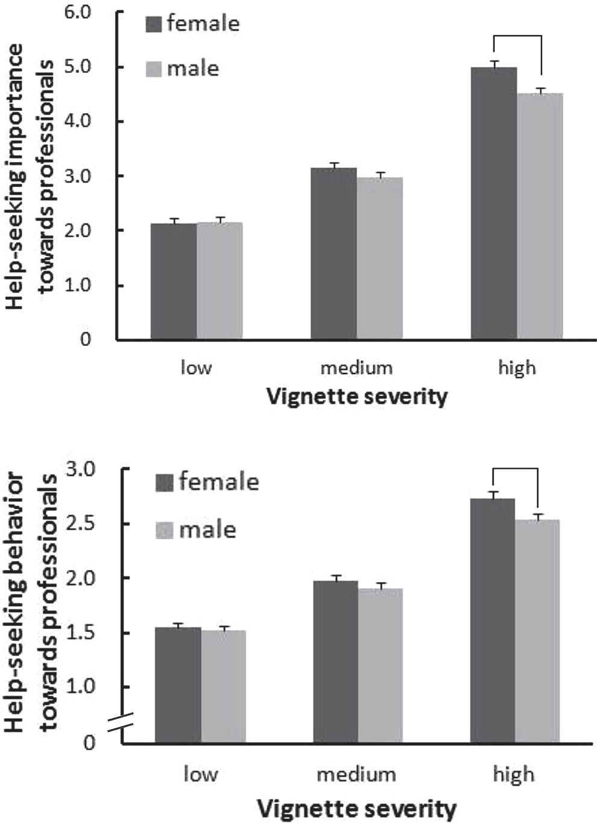

**

**

\**p*＜.05，\*\**p*＜.01，\*\*\**p*＜.001 \*\**p*＜.01

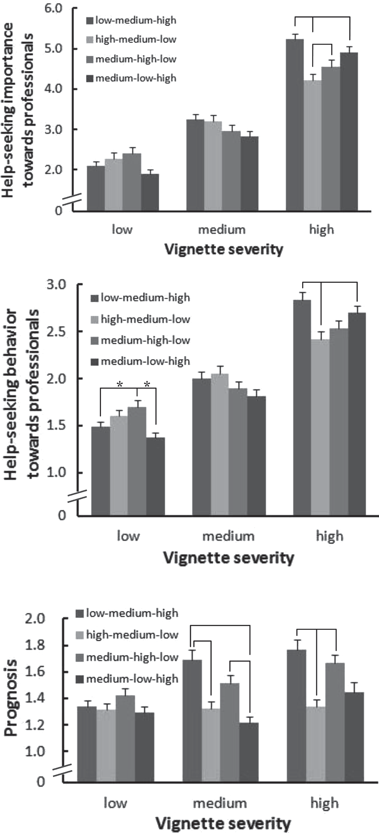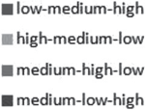

*** ***

*

** **

* *

**

**

** *

*

Figure 1. Interaction of vignette severity × sequence for

help-seeking importance and behavior towards mental health professionals and prognosis.

Figure 2. Interaction of gender × vignette severity for

help-seeking importance and behavior towards mental health professionals.

As a result of the test, the difference variable stake in importance and behavior was significantly greater in the condition of the friend than in my own condition (importance:

（*t* 1 372）＝3.06，*p*＜.01; 行動：（*t* 1 373）＝4.27，*p*＜.001）。

Evaluation of consultation and consultation behavior

consult or perhapsconsult with family and friends about situations with low, medium, or high conditions17.5%,38.4%,and69.6%, respectively. On the condition of friends, the percentage of respondents who said they would recommend a consultation or perhaps recommend a consultation 43.6%,85.4%,92.9It was %. orperhaps in the same way as you would like to see a doctor on your own terms

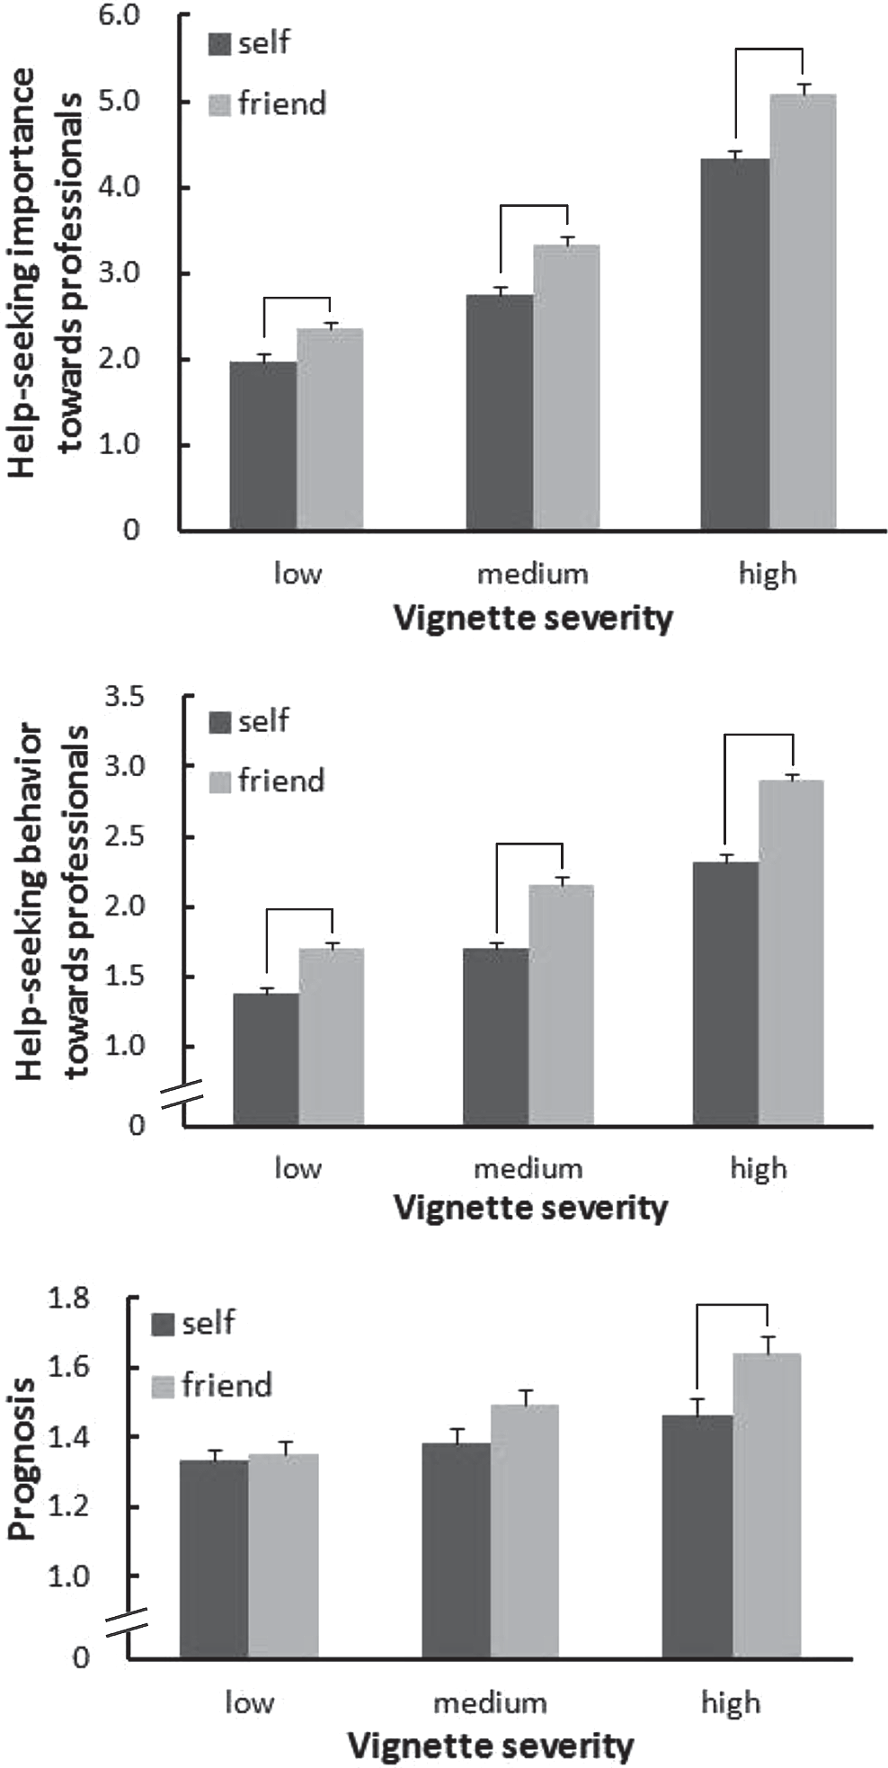

***

***

***

***

***

***

**

\*\**p*＜.01，\*\*\**p*＜.001

Figure 3. Interaction of target × vignette severity for

help-seeking importance and behavior towards mental health professionals and prognosis.

The percentage of respondents who said they would go to the clinic was 5.5%,11.6%,41.5%. In the condition of friends, the percentage who said that they would probably recommend acheck-upwas10.8. %,

27.0%,68.5%. aboutnine in the scene of the severity in

One in five people and less than half of the high-rise patients have visited the

Only about one in four people were advised to see a doctor when the severity was in the same case.

# Kaocha

In this study, the recognition when it was assumed that the university student exhibited depressive symptoms was compared with the case of one's own and the case of the friend by the subject who exhibited the symptom. As hypothesis 1, we consider that the optimistic cognitive bias shown in previous studies is seen in both non-professional and professional assistance requests, and hypothesis2 It was examined that the difference in the evaluation value for consultation and the examination in one's condition increases because of a large self-esteem threat.

A Study on Recognition of Optimistic Cognitive Bias and Depressive Symptoms

As a result of multivariate dispersion analysis by repeated measurements, the main effect of the severity of the scene was significant for both seriousness, the importance of consultation, consultation behavior, consultation behavior, and prognosis, and the evaluation value was significantly higher as the severity increased. It can be said that it is a result that the operation by the scene assumption method was done appropriately.

In addition, the main effect of the target is seen for any of the dependent variables, and it is higher in the condition of the friend than my own condition.

( Moreseriously, the request for assistance is more important)Slope to be evaluatedwas recognized. The results were consistent with the results of previous studies, and showed the effects of optimistic cognitive bias on the supposed evaluation of depressive symptoms in japanese university students,hypothesis1 was supported. In addition, the target

× From the study on the interaction of the severity of the scene, the importance of the examination, the behavior, and the prognosis were high when the severity was high in the condition of the friend, and the tendency to be judged poorly was clarified. With regard to requests for help from experts, it can be said that the higher the severity of the symptoms, the stronger the optimistic cognitive bias.

The optimism of cognition shown for depressive symptoms in the expected scene may be acting as a saboteur of the actual depression behavior of patients with depression. Elwy, Yeh, Worcester, &

Eisen(2011) conducted an interview survey of the affected patients who requested help and those who did not seek it, andDepression doesn't last long., and

It is reported that there was an optimistic recognition that it did not cause a big hindrance to daily life. Optimistic cognition of symptoms also seen in the affected patients may have emerged as optimistic cognitive bias in this study. On the other hand, awareness of the duration and treatment potential is

There are reports that it is not a predictor of requested behavior.

(Sherwood, Salkovskis, & Rimes, 2007), actual assistance requiredWhether optimistic cognitive bias acts as a saboteur of contract behavior, further targeting sufferers and depressed peopleThe accumulation of investigations is required.

The main effect of the order of presentation of the scene to the consultation behavior and the prognosis, and the importance of the examination, the examination behavior, the presentation order of the scene to the prognosis × from the examination on the interaction effect of the severity of the scene, the symptoms are gradual When the evaluation of the request for assistance and the prognosis increased when deteriorating, the evaluation tended to be lower when the symptoms gradually improved and the severity was high from the beginning. Therefore, it was thought that information about not only the symptom at that time but also the course of the symptom was used on the recognition of the help request and the prognosis. It is easy to recognize the importance of the request for assistance and the poor prognosis when the symptoms deteriorate over time, such as the order of low, medium, and high, but because there is a wave in the course of actual depressive symptoms, it was thought that the wave of the symptom sabotageed the recognition of the help request and the prognosis.

From the examination of sex, it became clear that women were more likely to recognize the importance of counseling than men, and to actually consult and encourage them. In addition, the importance of the examination and the main effect of sex on the examination behavior were not significant, but

× From the examination of the interaction of the severity of the scene, there was a tendency to recognize the importance of the examination as a woman in the scene with a high severity, and to answer that it actually consulted or recommended the examination. These results areconsistent with the results of many previous studies (Mizuno and Ishikuma,1999)that said that women are more likely to be helped thanmen. However, the interaction between gender xtargets was not significant. Although it was thought that the high level of the help-oriented in the woman might be related to the high intention to recommend the help request to others, the relation between the two has not been examined so much, and further examination is necessary.

Comparison of the difference in the evaluation value of consultation and consultation

Optimistic cognitive bias in aid request situations has traditionally been explained by theories about the threat to self-esteem (Raviv et al.,2000;Spendelow&Jose,2010I'm singing. Because the action of asking for help is considered to be a threat to self-esteem with the recognition and inferiority of the incompetence of the seeking side ( Fisher, Nadler, & Whitcher-Alagna, 1982;Nadler,1986,1987;Nadler&Fisher,1986I'm singing. Formal aid requests involve greater self-esteem threats than informal aid requests(Raviv et al., 2000) In this study, we hypothesized that the evaluation rate was lower when considering a consultation in their own condition, and that the difference between the evaluation values related to consultation increased compared to the friend conditions. However, compared to consultation, the importance of the examination and the evaluation of the behavior tended to fall on one's own conditions.

In the condition of friends, there was a similar tendency to fall, the difference was significantly larger than the friend condition, hypothesis 2was not supported. The following considerations should be made regarding the ideal way of recognition in non-professional and professional assistance requests.

A study from the self-esteem threat theory The result of this study can be explained from the conventional self-esteem threat theory.

First, it is possible that non-professional requests for assistance themselves pose a strong threat to self-esteem. Nadler & Fisher

(1986)According to the help from socially close donors, it is generally a self-esteem threat. Others who are socially close are more likely to have similar characteristics to themselves, and asking for help is an opportunity to think that they are inferior and incompetent compared to those who are similar. The nature of the problem and the relationship with the donor sway the idea that requests for help from family members and friends pose less a threat to self-esteem than a request to help experts may be overly simplistic.

It is also possible that a request for help from a specialist may not necessarily pose a major threat to self-esteem. Doctors and psychologists act as specialist services, making it easier for non-professionals to take the role of donors (Sueki,2008I'm singing. Understanding of such mechanisms may reduce the threat to self-esteem in professional assistance requests.

In addition, it can be thought that the action which encourages the request for help poses a threat to self-esteem. In situations where there are others who think they should make a request for help, one tries to be useful in some way, and by power, he gains joy and maintains self-respect(Dovidio, 1996 I'm singing. Introducing aid resources is also considered to be a useful way for those in need. However, if the resources introduced are not appropriate for the donor, they may not be useful, and receiving negative evaluations from the donors may threaten their self-esteem as a result. The decision of whether an aid resource is appropriate is considered to be dependent on the knowledge and amount of information about the resource,and the introduction of the aid resource without sufficient information carries the risk of becoming a threat to self-esteem. Therefore, it is possible that the action to recommend assistance itself poses a threat to self-esteem, and therefore the evaluation value for the examination in the condition of the friend became small.

A study from the equitable theory The result of this study is equitable theory

(Adams, 1963)It is considered to be possible to explain from. In equitabletheory, aid actionisconsidered a conflict ofinterest. In relation to donors who lose benefits due to the cost of aid actions, the recipients who receive benefits are placed in an equitable state due to over-remuneration. Because inequality leads to psychological distress, it is motivated to eliminate and reduce it (Harada,2001).

The psychological burden of inequality stems fromtwo things: anxiety about the return report and the threatto self-esteem.

(Walster, Berscheid, & Walster, 1973)In addition, the In the context of the letter of the request for assistance, it is necessary to return the report in order to eliminate the inequality created by receiving assistance, but it is possible that the request for assistance will be avoided because the specific method of return is not known. It is thought that the request for help will not be promoted without the strategy to reduce the sense of psychological debt felt by receiving help. This tendency is weak in requests for assistance to specialists whose methods of returning treatment and assistance services (payment of compensation) are clear, and non-professional assistance is made to family and friends. may be strengthened in the request. However, the results of this study can be interpreted from the standpoint of the equitable theory of avoiding equitable states with anxiety about the return to aid.

Based on both theories, hypothesis2 is considered to be interpreted from the standpoint of self-esteem threat theory and equitable theory as described above as a factor in the not supported. It is necessary to examine the background that the result different from the previous research might have influenced the cultural difference in the way of the self-esteem and the approach to the professional and non-professional help in the future.

The Limits of This Study and future prospects

In this study, we conducted a questionnaire survey using a scene-assuming method, but not a standardized questionnaire. However, the results of this study are generally consistent with the results of prior studies, and it is believed that some validity is ensured. In addition, this study is an analog study that does not measure the actual requested behavior of people with suppressive symptoms or depression sufferers. As a cause of optimistic cognitive bias, the ease of access to information about self has been discussed(Shepperd, Carroll, Grace, & Terry,

2002)Self-awareness at the time of the study of the study subjects who can say that they are healthy to the extent that they can attend at least auniversity

( Currentlyin good health, no major problems, etc.)the reputation of may have affected the In addition, if you do not assume a particular other, it is known that one has a inclination to compare with the relatively vulnerable others (Perloff &Fetzer,

1986). In this study, we only specified the subject son-in-one comparison with the friend, so it is possible that the comparison was made with a relatively vulnerable subject. However, it can be thought that such a phenomenon also represents one aspect of optimistic cognitive bias. In addition, the gender of the friend you assumed as a target may have influenced the results. In the future, it will be important to examine not only the gender of the evaluator, but also the influence of the target's sex. In addition, this survey is conducted for university students at four-year universities in the Tokyo metropolitan area, and attention is required on the possibility of generalization of the results.

Although there are limits as described above, this study is easy for university students to consider requests for help with depressive symptoms.

It is thought that it is significant in the point that it is clarified that the cognitive bias works, and the factor which influences the recognition of the symptom is examined from the viewpoint of the self-esteem threat theory and the equitable theory. Although there was a difference in the condition of one's own condition and the friend condition, it is important to continue the transmission of correct knowledge and information about depressive symptoms because it was answered that many subjects do not consult or consult even in situations where the severity is relatively high. Moreover, it is possible to promote more appropriate self-monitoring by communicating to the general public that it is likely to recognize one's own symptoms optimistically by all means. Furthermore, it is thought that it is connected with the promotion of the understanding of the symptom of the person and the request for help by communicating that others around the person can evaluate more realistically.

As a future direction, it is conceivable to measure the depression level of the subjects surveyed, the presence or absence of a medical examination history, and the relationship between how to catch symptoms and the relationship between optimistic cognitive bias. Moreover, by examining the psychological and social variables of the survey subjects together, it will be possible to understand and approach them in line with the attributes of the subjects.

Citations

Adams, J. S. (1963). Towards an understanding of inequity. *Journal of Abnormal and Social Psycholo*- *gy*, **67**, 422-436.

MitsuruAikawa(1989). Aid Action Ikuo Obo, Kiyoshi Ando,

Kenichi Ikeda (ed.)Perspective on Social Psychology1

From Individuals to Others Seishin Shobopp. 291-311.

（Aikawa, M.）

Beck, A. T., & Beck, R. W. (1972). Screening depressed

patients in family practice: A rapid technique.

*Postgraduate Medicine,* **52**, 81-85.

Cauce, A.M., & Srebnik, D. (2003). Before treatment:

Adolescent mental health help-seeking. *Prevention Researcher,* **10**, 6-9.

Ciarrochi, J., Deane, F. P., Wilson, C. J., & Rickwood,

D. (2002). Adolescents who need help the most are the least likely to seek it: The relationship between

low emotional competence and low intention to seek help. *British Journal of Guidance & Counselling,*

**30**, 173-188.

Dovidio, J. F. (1996). Helping behavior. In A. S. R. Manstead & M. Hewestone (Eds.), *The Blackwell encyclopedia of social psychology.* Massachusetts:

Blackwell Publishers. pp. 290-295.

Elwy, A. R., Yeh, J., Worcester, J., & Eisen, S. V. (2011). An illness perception model of primary care patientsʼ help seeking for depression. *Qualitative Health Research*, **21**, 1495-1507.

Fisher, J. D., Nadler, A., & Whitcher-Alagna, S. (1982). Recipient reactions to aid. *Psychological Bulletin*, **91**, 27-54.

Friedrich, J. (1996). On seeing oneself as less self-

serving than others: The ultimate self-serving bias?

*Teaching of Psychology*, **23**, 107-109.

Gulliver, A., Griffiths, K. M., & Christensen, H. (2010). Perceived barriers and facilitators to mental health help-seeking in young people: A systematic review. *BMC Psychiatry*, **10**, 113-121.

原田 純治（2001）．援助行動 土田 昭司（編）対人

Social Psychology of Behavior —The Mind and Behavior between People—Kitaoji Shobopp. 73-81.

(Harada, J.)

久田 満（2000）．社会行動研究 2 ──援助要請行動の研究── 下山 晴彦（編）臨床心理学研究の技法 福 村 出 版 pp. 164-170．

（Hisada, M.）

Kento Kawakami(2003). Research On the Actual Conditions of Mental Health Problems and The Basis of CountermeasuresResearch ReportHeisei14Grant-in-Aid forScientific Research ( Special Research Project for Health, Labour and Welfare Science)

（Kawakami, N.)

Kushner, M. G., & Sher, K. J. (1991). The relation of

treatment fearfulness and psychological service

utilization: An overview. *Professional Psychology: Research and Practice*, **22**, 196-203.

Haruhisa Mizuno and ToshinoriIshikuma(1999). Aid-oriented,

Trends in Research on Assisted Behavior Education Psychology Research,

**47**，530-539．

（Mizuno, H., & Ishikuma, T. (1999). Help-seeking

preferences and help-seeking behaviors: An over-

view of studies. *Japanese Journal of Educational Psychology,* **47**, 530-539.）

Nadler, A. (1986). Self-esteem and the seeking and

receiving of help: Theoretical and empirical per-

spectives. *Progress in Experimental Personality Research*, **14,** 115-163.

Nadler, A. (1987). Personality and situational variables

as determinants of help-seeking. *European Journal of Social Psychology*, **17**, 57-67.

Nadler, A. (1991). Help-seeking behaviour: Psychologi-

cal costs and instrumental benefits. In M. Clark (Ed.), *Prosocial behavior.* Newbury Park: Sage. pp. 290-312.

Nadler, A., & Fisher, J. D. (1986). The role of threat to

self-esteem and perceived control in recipient

reaction to aid: Theory development and empirical validation. In L. Berkowitz (Ed.), *Advances in experimental social psychology*. Vol. 19. New York: Academic Press. pp. 88-122.

Perloff, L. S., & Fetzer, B. K. (1986). Self-other

judgments and perceived vulnerability to victimiza-

tion. *Journal of Personality and Social Psychology*,

**50**, 502-510.

Raviv, A., Sills, R., Raviv, A., & Wilansky, P. (2000). Adolescentsʼ help-seeking behavior: The difference between self- and other-referral. *Journal of Adoles*-

*cence,* **23**, 721-740.

Rothman, A. J., Klein, W. M., & Weinstein, N. D. (1996). Absolute and relative biases in estimations of personal risk. *Journal of Applied Social Psycholo*- *gy*, **26**, 1213-1236.

Schonert-Reichl, K. A. (2003). Adolescent help-

seeking behaviors. *Prevention Researcher*, **10**, 1-5.

Shepperd, J. A., Carroll, P., Grace, J., & Terry, M. (2002). Exploring the causes of comparative optimism. *Psychologica Belgica*, **42**, 65-98.

Sherwood, C., Salkovskis, P. M., & Rimes, K. A. (2007). Help-seeking for depression: The role of beliefs, attitudes and mood. *Behavioral and Cog*- *nitive Psychotherapy*, **35**, 541-554.

Spendelow, J. S., & Jose, P. E. (2010). Does the

optimism bias affect help-seeking intentions for

depressive symptoms in young people? *Journal of General Psychology*, **137**, 190-209.

Srebnik, D., Cauce, A.M.,&Baydar,A.(1996).Help-

seeking pathways for children and adolescents.

*Journal of Emotional and Behavioral Disorders*, **4**, 210-220.

Stefl, M. E., & Prosperi, D. C. (1985). Barriers to

mental health service utilization. *Community Mental Health Journal*, **21**, 167-178.

Sueki Shin(2008). Request for help with psychological support

動の意思決定要因 臨床心理学，**8**，843-858．

（Sueki, H. (2008). Decision-making factors in

emotional help-seeking: An influence of recognition

of a friend. *Japanese Journal of Clinical Psychology*,

**8**, 843-858.）

Akira Takano and ReiUrada(2002). StudentConsultation as a Service from the Viewpoint of Request for Assistance Education Psychology Studies, **50,**113-125 The .

（Takano, A., & Uruta, U. (2002). Student coun-

seling as a service: From the point of view of help-

seeking behavior. *Japanese Journal of Educational Psychology*, **50**, 113-125.）

YusukeUmegaki(2011). How Depressed Patients Have Depression

Qualitative study on the process of disease formation before consultation—Clinical psychology,**11**, 383-395.The .

（Umegaki, Y. (2011). How do depressive patients

recognize their illness before seeing a doctor? The

process of development of insight in major depressive disorder patients. *Japanese Journal of*

*Clinical Psychology*, **11**, 383-395.）

Walster, E., Berscheid, E., & Walster, G. W. (1973).

New directions in equity research. *Journal of Personality and Social Psychology*, **25**, 151-176.

Weinstein, N. D. (1980). Unrealistic optimism about

future life events. *Journal of Personality and Social Psychology*, **39**, 806-820.

── 2011. 11. 18 受稿，2012. 7. 7 受理──

**Appendix**

Sentences used for scene assumptions (presentation order: low, medium, high) and symptoms shown by each

Overall, there is nothing particularly wrong with my mood, and I don't feel sad or blame myself. However, i feel a little less restless than usual, and i feel always nervous. You don't feel like you're worthless, you don't hurt yourself, and you don't feel like you're being punished for what you've done. However, i am a little less motivated than usual and sleep longer than usual. Don't cry more than usual. In other respects, there is no problem, and the interest in the opposite sex does not change as usual. Even in situations where we decide things, it's never more difficult to make than usual.

(Symptoms: impatience, restlessness, tension, lethargy, sleep disorder)

After a month, I was not very motivated, i felt exhausted, and i was not able to do as usual. I sleep much longer than usual and am very irritated. It's quite difficult to make decisions when you make decisions, and it's hard to focus on one thing. However, there is a part which does not change usually, and the concern for the opposite sex is usual, and there is not always crying above. You don't want to hurt yourself. But when I think about the past, I see a lot of failures, and I realize that I am disappointed with my present self and are always blaming my shortcomings.

(Symptoms: lethargy, fatigue, sleep disorder, impatience, difficulty deciding, difficulty concentrating, failure, self-loathing, disappointment, self-criticism)

After a month, I don't feel at all happy about what I've been enjoying, and I feel like I'm being punished. I don't like myself, and whenever something bad happens, I blame myself. It's restless, frustrating, and it's not always moving, but on the other hand, it doesn't give you the motivation to do anything. It's getting harder and harder to do things that have been done normally. I spend most of my day sleeping, have no appetite, have no interest in the opposite sex, and it is very difficult to decide things. I just feel like crying, but I can't even cry.

(Symptoms: loss of pleasure, sin feelings, self-loathing/ disappointment, self-criticism, impatience, restlessness and tension, lethargy, sleep disorder, loss of appetite, decreased interest in sex, difficulty deciding,depressed mood)